**roject Design Phase-II**

**Solution Requirements(Functional & Non-functional)**

|  |  |
| --- | --- |
| Date | 03 October 2022 |
| Team ID | PNT2022TMID11549 |
| Project Name | Project –Smart Waste Management for Metropolitan Cities |
| Maximum Marks | 4 Marks |

**Data Flow Diagrams:**

A Data Flow Diagram (DFD) is a traditional visual representation of the information flows within a system. A neat and clear DFD can depict the right amount of the system requirement graphically. It shows how data enter and leaves the system, what changes the information, and where data is stored.

A smart waste management uses analytics to translate the data.

* The test conducted is the situation where the garbage bin is empty or its garbage level is very low.
* Then, the bin is filled.
* The notification is sent by the system.
* The garbage needs to be collected immediately.
* Location prone to overflow.
* The number of bins needed to avoid overflowing waste.
* The number of collection services that could be saved.
* The amount of fuel that could be saved.
* The driving distance that could be saved.
* No missed pickups of trashcans.
* New smart dustbins can be install by just connecting the IoT device to the cloud.

**Example:**

**Data Flow Diagram**

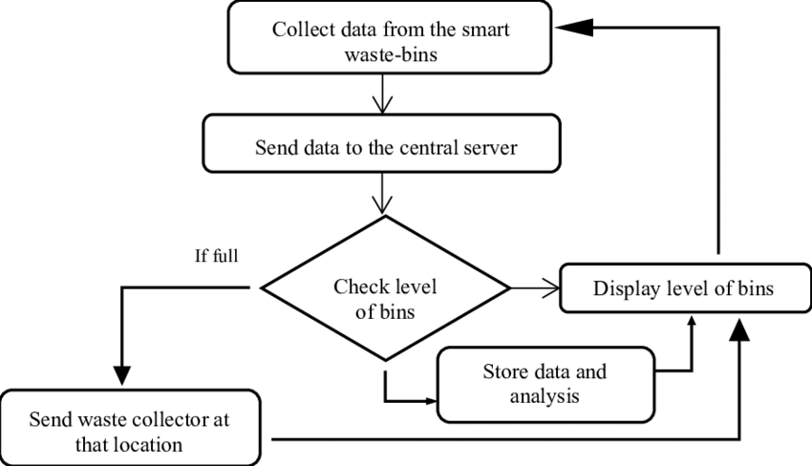

**User Stories**

Use the below template to list all the user stories for the product

| **User Type** | **Functional Requirement (Epic)** | **User Story Number** | **User Story / Task** | **Acceptance criteria** | **Priority** | **Release** |
| --- | --- | --- | --- | --- | --- | --- |
| Admin | Login | USN-1 | Admin gives a user id and password for each and every workers and helps to manage | I can access my account / dashboard | Medium | Sprint-2 |
| Assistant Admin | Login | USN-2 | They help us to monitor the garbage level once it is filled alert message will be thrown with location | I can manage and monitor the garbage level | High | Sprint-1 |
| Driver | Login | USN-3 | They will follow the location where the garbage is filled and collect them in the truck | I can drive to reach the garbage where it is filled using location and collect them | Medium | Sprint-2 |
| Garbage Collector | Login | USN-4 | It will collect the trash and load it into the garbage truck and send to landfill | I can collect the trash and load them in truck | Medium | Sprint-2 |
| Government Municipality | Login | USN-5 | It will check the process without involving any issues | I can manage the process smoothly | High | Sprint-1 |
|  |  | | | | | |
|  |